Amazon Product Co-Purchasing Network Analysis
Week 4 – Individual Class Exercise
Dataset: amazon_sampled_graph.csv
1. Introduction
For this exercise I analyzed an Amazon product co-purchasing network using Gephi. The idea behind the dataset is straightforward – if two products are frequently bought together by customers on Amazon, they share an edge in the graph. Each product is a node, and each co-purchasing relationship is an undirected edge connecting two nodes. The objective was to load this data into Gephi, run several graph metrics, detect communities, and pull out meaningful insights about how products relate to each other in the network.
2. Dataset Overview
After importing the CSV file into Gephi as an undirected graph, the basic network statistics came out as follows:

Metric | Value
Total Nodes (Products) | 1,000
Total Edges (Co-purchases) | 2,178
Graph Type | Undirected
Average Degree | 4.356
Network Diameter | 8
Average Path Length | 5.063
Modularity Score | 0.742

The network is reasonably sparse – with 1,000 products and only 2,178 co-purchasing links, most products are only bought alongside a handful of others. That said, a small number of products are connected to hundreds of others, which becomes very apparent once you visualize the graph.
3. Graph Visualization
I used the ForceAtlas2 layout algorithm to arrange the graph. This algorithm works like a physics simulation – connected nodes are pulled toward each other while unconnected ones push apart – which naturally causes tightly knit product groups to cluster together. I ran it for about 30 seconds until the graph stabilized, then turned on Prevent Overlap to keep nodes from sitting on top of each other.
To make the visualization easier to read, I sized each node proportionally to its degree, so popular hub products appear as larger circles. Edge thickness was kept thin (0.5) so the connections don’t visually overwhelm the nodes. The result is a graph where you can clearly see a dominant central cluster surrounded by smaller satellite groups.
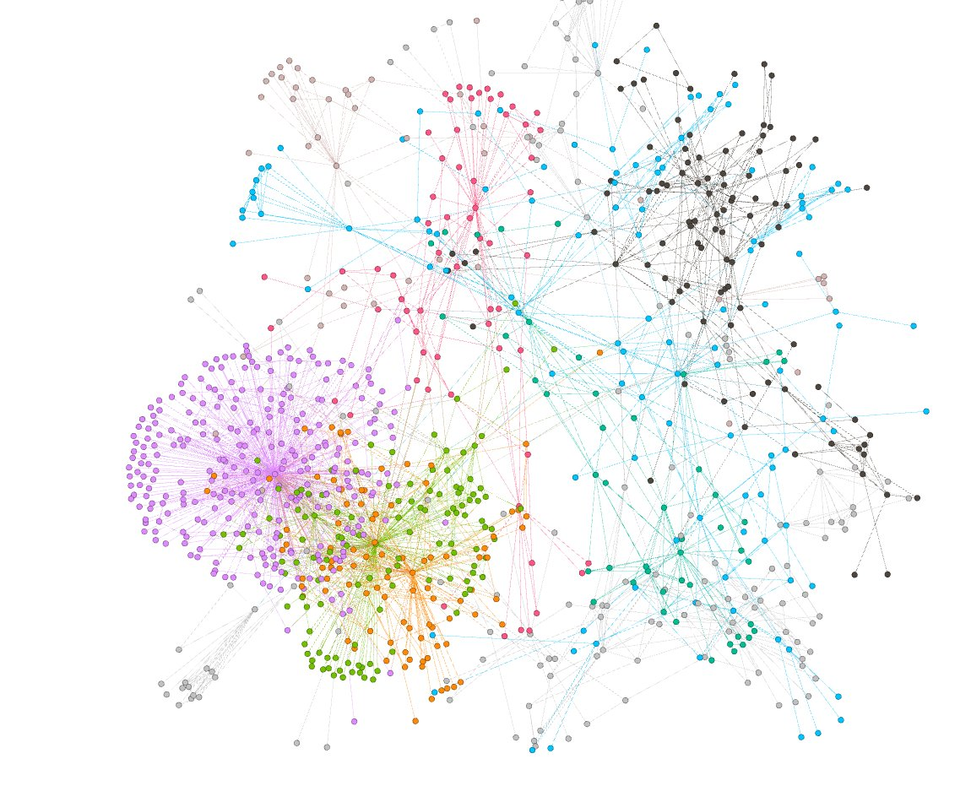
After running community detection (covered in Section 6), nodes were colored by their community membership, making the product groupings immediately obvious:

Figure 1: Graph after ForceAtlas2 layout with nodes colored by community (Modularity Class)
4. Degree Analysis
Degree simply counts how many direct connections a node has. In this network, a high degree means a product is co-purchased alongside many other products – essentially an Amazon bestseller or a universal add-on that pairs well with almost anything.
I ran the Average Degree statistic in Gephi and then sorted the Nodes table in Data Laboratory by degree (descending). Here are the results:
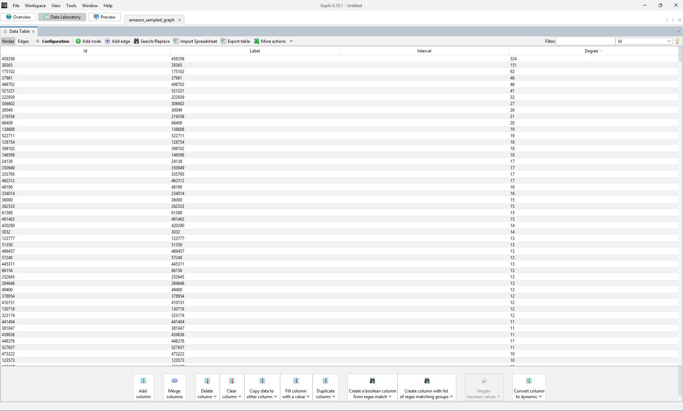

Figure 2: Data Laboratory sorted by Degree (descending) – top nodes visible at the top

Rank | Node ID | Degree | What this means
1 | 458358 | 324 | Super-hub, dominant product
2 | 38365 | 151 | Major hub
3 | 175102 | 92 | Secondary hub
4 | 37981 | 46 | Minor hub
5 | 498702 | 46 | Minor hub

Node 458358 is in a league of its own – with 324 connections it has more than double the degree of the second-ranked node (38365 at 151). This kind of extreme imbalance is a classic sign of a scale-free network, where a tiny number of "super-hubs" hold the network together. In Amazon’s context, this product is likely something very general – maybe a USB cable, a popular book series, or a household essential that gets bundled with almost everything.
5. Centrality Measures
After running Network Diameter and PageRank from the Statistics panel, the Data Laboratory was populated with new columns for Betweenness Centrality and PageRank. Here’s a screenshot of the full table:
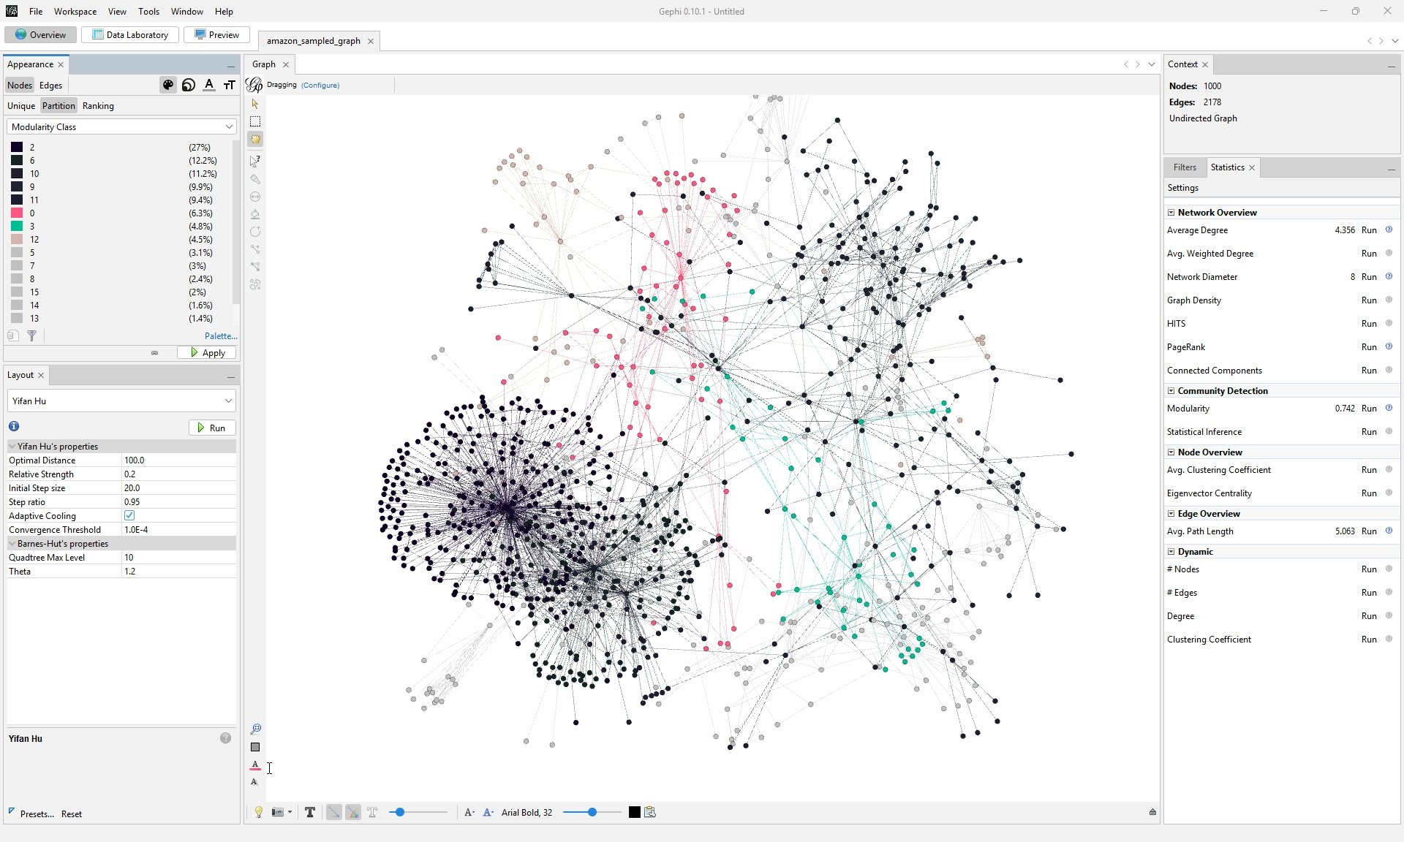

Figure 3: Data Laboratory showing Degree, Betweenness Centrality, and PageRank columns

5.1 Betweenness Centrality
Betweenness centrality measures how often a node acts as a bridge on the shortest path between other nodes. Think of it like a traffic intersection – a node with high betweenness is one that a lot of "routes" pass through. If you remove it, many parts of the network become harder to reach from each other.

Rank | Node ID | Betweenness | Role in network
1 | 458358 | 235,624.8 | Hub and bridge
2 | 58064 | Very high | Silent bridge node
3 | 24139 | High | Silent bridge node
4 | 522711 | Moderate-high | Community connector
5 | 38365 | Moderate | Hub and bridge

What stood out to me here was nodes 58064 and 24139. They have fairly low degree (they’re not popular products), but they score extremely high on betweenness. That means they sit on critical paths between communities. In real terms, these are niche products that happen to be the only "link" between two separate product categories. If Amazon removed them from its recommendation engine, two clusters of products would become isolated from each other.
5.2 PageRank
PageRank doesn’t just count connections – it also considers the importance of the nodes you’re connected to. A product linked to many other popular products scores higher than one linked to obscure ones, even if both have the same raw degree count.

Rank | Node ID | PageRank | Significance
1 | 458358 | 0.0694 | Most influential overall
2 | 38365 | 0.0334 | Highly influential
3 | 175102 | 0.0194 | Influential
4 | 521221 | 0.0095 | Moderate influence
5 | 498702 | 0.0088 | Moderate influence

Again, node 458358 comes out on top with a PageRank of 0.0694 – nearly double the second-place node. This confirms it isn’t just connected to many products, it’s connected to important ones. It really is the center of gravity for this entire network.
6. Community Detection
I ran the Modularity algorithm in Gephi with default settings (resolution = 1.0) to detect communities. The algorithm groups nodes so that connections within groups are denser than connections between groups. A modularity score closer to 1 means the communities are clearly defined.
The result was a modularity score of 0.742, which is genuinely strong – anything above 0.7 typically indicates well-separated, meaningful communities. Gephi identified 16 communities in total. The five largest ones covered about 46% of all nodes between them.

Community | Approx. Nodes | % of Network | Color in Graph
1 | ~241 | 24.1% | Purple
2 | ~218 | 21.8% | Dark/Black
3 | ~95 | 9.5% | Pink
4 | ~61 | 6.1% | Teal
5 | ~59 | 5.9% | Orange

After applying community colors in the Appearance panel (Partition → Modularity Class), the graph immediately became much more readable. You could visually distinguish the product clusters, with the two dominant communities making up the dense core of the graph and the smaller communities appearing as peripheral clusters.
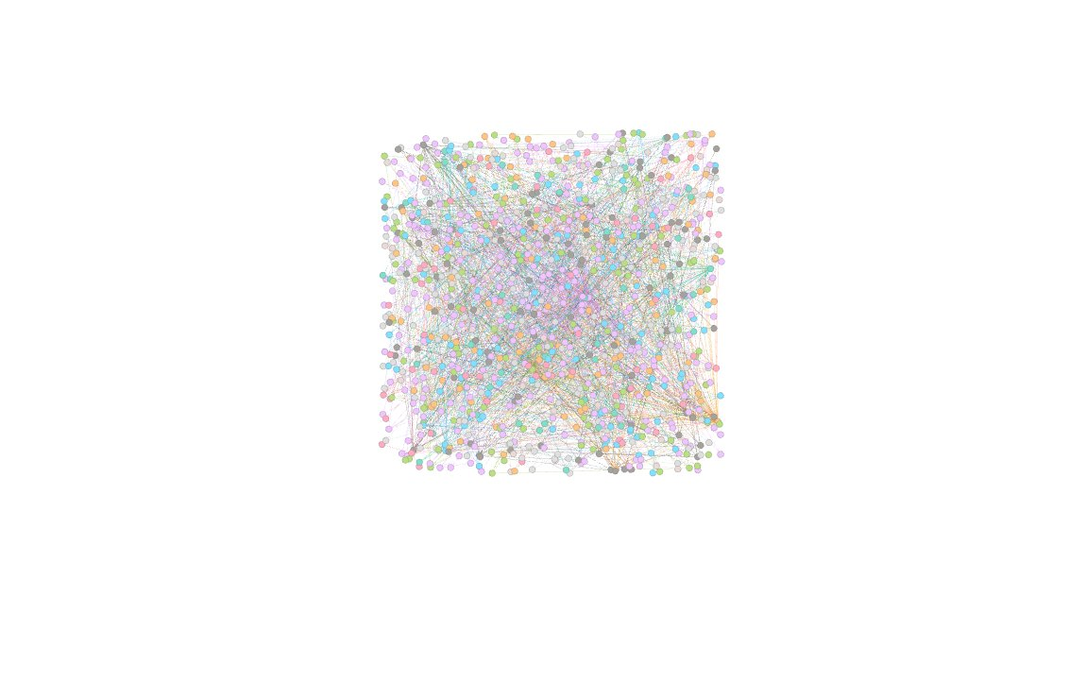

Figure 4: Community detection result with nodes colored by Modularity Class

7. Filtering and Highlighting
7.1 High Betweenness Centrality Nodes
Using the Filters panel in Gephi I isolated nodes with high betweenness centrality by applying a degree range filter (setting the minimum to ~50). This left only the hub nodes visible and made it easy to observe how they connect different parts of the graph. The bridge nodes (58064 and 24139) were particularly interesting – despite not being highly connected products themselves, they were the only link between several otherwise disconnected communities. In a real Amazon recommendation system, these products would be excellent cross-category recommendation triggers.
7.2 Top 5 Degree Nodes – Colored Black and Enlarged
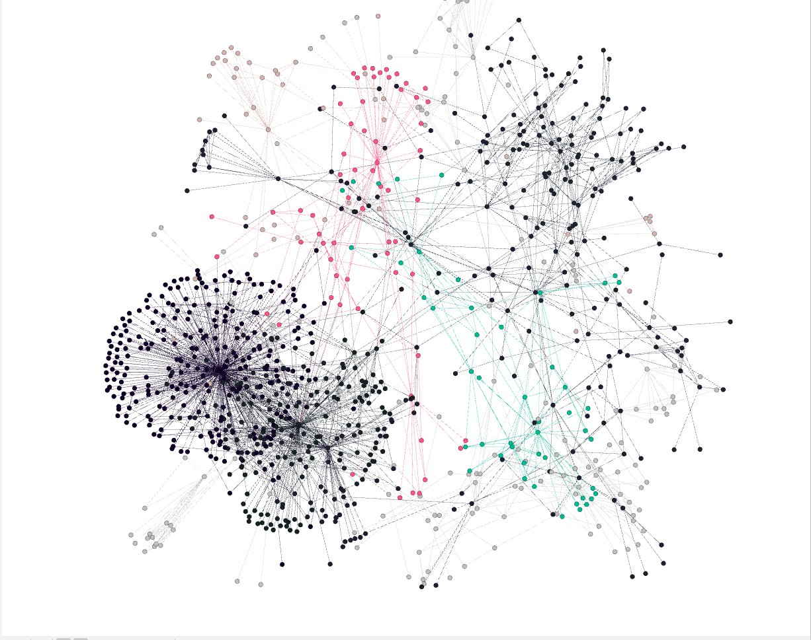
As the final styling step, I manually selected the top 5 degree nodes (458358, 38365, 175102, 37981, and 498702) and colored them black with a much larger size (80 vs. the average ~10). The result makes the hub nodes immediately obvious even from a zoomed-out view. Node 458358 in particular is impossible to miss – it sits at the gravitational center of the entire left cluster with lines radiating out in every direction.

Figure 5: Final graph with top 5 highest-degree nodes colored black and enlarged for emphasis
8. Key Takeaways
Looking at everything together, a few things stood out from this analysis:

- The network is scale-free. A tiny handful of products have hundreds of connections while most have only a few. This matches what you’d expect in real purchasing behavior – a few universal products dominate while most are niche.
- Node 458358 is the undisputed center of this network. It ranks first in degree, betweenness centrality, and PageRank all at once. It’s not just popular – it’s structurally critical to the entire graph.
- High betweenness doesn’t always mean high degree. Nodes 58064 and 24139 are relatively obscure products, but they serve as the only connectors between separate product communities. They’re critical bridge points that most people would overlook.
- The community structure is very strong (modularity 0.742). The 16 detected communities likely represent distinct product categories or customer interest groups. The two largest communities alone account for nearly half the network.
- The network has small-world properties. With an average path length of just 5.063 and a diameter of 8, almost any product can reach any other within a few co-purchasing hops. This is exactly why Amazon’s recommendation engine works so well – the product graph is naturally highly navigable.

Overall this was a really useful exercise for seeing how graph analysis can reveal structure that you simply wouldn’t spot by looking at raw data. The combination of degree analysis, centrality metrics, and community detection painted a clear picture of how Amazon’s co-purchasing ecosystem is organized – a few dominant hubs, a handful of hidden bridge products, and well-defined product category clusters all operating together within a tightly connected network.

